**Shri B.V.V.Sangha’s**



**BASAVESHWAR ENGINEERING COLLEGE (AUTONOMOUS), BAGALKOT-587 102**



**DEPARTMENT OF COMPUTER SCIENCE & ENGINEERING**

**For the academic year 2020-2021**

**Seminar Report on**



**Under the Guidance of Seminar Coordinator Head of the Department Prof. S. S. Yendigeri Prof. P. Madhavanavar Dr.V.B. Pagi**

**Submitted by:**

**Name USN**

**Shrinidhi Puranik 2BA17CS091**

**Shri B.V.V.Sangha’s**

**BASAVESHWAR ENGINEERING COLLEGE (AUTONOMOUS), BAGALKOT-587 102**



**DEPARTMENT OF COMPUTER SCIENCE & ENGINEERING**

**For the academic year 2020-2021**

# CERTIFICATE

This is to certify that Mr. Shrinidhi Puranik (2BA17CS091) has satisfactorily completed the seminar report on ,

for the fulfillment of their courses in Computer Science and Engineering as prescribed by Basaveshwar Engineering College(Autonomous), Bagalkot during the academic year 2020-2021.

PLACE: Bagalkot DATE:

**-------------------------**

**-----------------------**

**-------------------------**

**Under the Guidance of Seminar Coordinator Head of the Department Prof. S. S. Yendigeri Prof. P. Madhavanavar Dr.V.B. Pagi**



**ACKNOWLEDGMENT**



I have taken efforts in this project. However, it would not have been possible without the kind support and help of many individuals and organizations. I would like to extend my sincere thanks to all of them.

We thank our beloved Principal Dr. S.S.Injaganeri sir for his constant help and support throughout. Our special thanks to our Head of the department Dr. V. B. Pagi sir who supported us in making this project a successful one. I would like to express my gratitude towards Prof. P.B. Madhavanavar sir for their kind co-operation and encouragement which helped me in completion of this project. I am highly indebted to Prof. S.S. Yendigeri ma’am for their guidance and constant supervision as well as for providing necessary information regarding the seminar & also for their support in completing this report.

We would like to thank all the teaching and non-teaching staff of department of Computer Science and Engineering for their coordination and support.

# ABSTRACT



Artificial intelligence (AI) is the hottest topic of the decade with its applications being used everywhere in our lives. AI is the intelligence demonstrated by machines and it is currently a driving technology and is being researched by many companies. OpenAI is one such company which was founded in 2015 by Elon Musk and Sam Altman. OpenAI has a division called OpenAI Inc, which is a non-profit artificial intelligence research laboratory that conducts research in the field of AI with the stated goal of promoting and developing friendly AI in a way that benefits humanity as a whole. What is peculiar about OpenAI is that it was Open-sourced, Its fun experiments with AI and its mission to ensure Artificial General Intelligence (AGI). AGI is the hypothetical ability of an intelligent bot or agent to understand and learn any task that a human can and possibly outperform them in their own fields of expertise.

Two such scenarios where they set the benchmark of AGI was when they made bots play hide and seek with each other, where the bots were trained on reinforcement learning and learned from their mistakes in the game and developed human like characteristic behaviors. Another scenario consist off a bot named OpenAI Five which could play an online complex real time strategy game called Dota 2 and was successful in beating the professional in their own fields multiple times. Hence showing the potential of AGI in coming closer to the human intelligence in the coming years.

# TABLE OF CONTENT



|  |  |  |
| --- | --- | --- |
| **Chapter** | **Headings** | **Page no.** |
| **01** | **1. Introduction** | **1** |
| **02** | 1. **What is OpenAI ?**    1. **Introduction**    2. **History**    3. **Motives and Strategy**    4. **Products and Applications** | 2 |
| **03** | 1. **What is AGI ?**    1. **Introduction**    2. **Characteristics** | 4 |
| **04** | **4. Scenario 1: AI showing Human Behaviors** | 5 |
| **05** | **5. Scenario 2: AI Beating Humans** | 8 |

**LIST OF FIGURES**



|  |  |  |
| --- | --- | --- |
| **Fig. No.** | **Figure** | **Page No.** |
| 4.1 | Fig 4.1 The environment created to train the bots | 5 |
| 4.2 | Fig 4.2 Mechanisms followed by the agents | 6 |
| 4.3 | Fig 4.3 Seekers learned to block paths | 6 |
| 4.4 | Fig 4.4 Seekers learned to take the ramp in | 6 |

# CHAPTER 1: INTRODUCTION



Artificial Intelligence is the study of how to make computer do things which at the moment people do it better. Primary goal of artificial intelligence is to improve computer behavior so that it can be called intelligent. The beginnings of modern AI can be traced to classical philosophers' attempts to describe human thinking as a symbolic system. But the field of AI wasn't formally founded until 1956.

Computer science defines AI research as the study of "intelligent agents" any device that perceives its environment and takes actions that maximize its chance of successfully achieving its goals. A more elaborate definition characterizes AI as "a system's ability to correctly interpret external data, to learn from such data, and to use those learnings to achieve specific goals and tasks through flexible adaptation.

Nowadays AI-enhanced technologies and solutions are now more widely available than before across industries, such as profiting for revenue increases for inventory and optimization, pricing and promotion, customer-service analytics, and sales and demand forecasting for businesses alone, though they are not necessarily cheap to implement. Because of most Research and development of AI solution is kept a secret and sold for huge money. In the decade of AI being used as an important asset, OpenAI came in as an open-sourced non-profit artificial intelligence research laboratory under the leadership of Elon Musk and Sam Altman.

1

# CHAPTER 2: WHAT IS OPENAI ?



* 1. **Introduction**

OpenAI is an artificial intelligence (AI) research laboratory consisting of the for- profit corporation OpenAI LP and its parent company, the non-profit OpenAI Inc. The company, considered a competitor to DeepMind, conducts research in the field of AI with the stated goal of promoting and developing friendly AI in a way that benefits humanity as a whole. The organization was founded in San Francisco in late 2015 by Elon Musk, Sam Altman, and others, who collectively pledged US$1 billion. Musk resigned from the board in February 2018 but remained a donor. In 2019, OpenAI LP received a US$1 billion investment from Microsoft.

# History

In October 2015, Elon Musk, Sam Altman, and other investors announced the formation of OpenAI and pledged over US$1 billion to the venture. The organization stated they would "freely collaborate" with other institutions and researchers by making its patents and research open to the public. On February 21, 2018, Musk resigned his board seat, citing "a potential future conflict (of interest)" with Tesla AI development for self driving cars, but remained a donor and is currently lead by Sam Altman alone. In 2019, OpenAI transitioned from non-profit to for-profit and partnered with Microsoft Corporation, who announced an investment package of US$1 billion into the company. OpenAI then announced its intention to commercially license its technologies, with Microsoft as its preferred partner.

# Motives and Strategy

OpenAI stated that their mission is to ensure that artificial general intelligence (AGI)—by which we mean highly autonomous systems that outperform humans at most economically valuable work—benefits all of humanity. They will attempt to directly build safe and beneficial AGI, but will also consider our mission fulfilled if our

work aids others to achieve this outcome. Musk and Altman have stated they are motivated in part by concerns about the existential risk from artificial general intelligence. OpenAI states that it's hard to fathom how much human-level AI could benefit society, and that it is equally difficult to comprehend how much it could damage society if built or used incorrectly. Research on safety cannot safely be postponed because of AI's surprising history, it's hard to predict when human-level AI might come within reach. OpenAI states that AI should be an extension of individual human wills and, in the spirit of liberty, as broadly and evenly distributed as possible



# Products and Applications

* + - **Gym:** Gym is a toolkit for developing and comparing reinforcement learning algorithms. It supports teaching agents everything from walking to playing games like Pong or Pinball.
    - **RoboSumo:** A virtual humanoid robots initially lack knowledge to do any task but can learn any tasks assigned to them. In this case, task of a sumo to push the other bot out of the ring.
    - **Debate Game:** which teaches machines to debate toy problems in front of a human judge.
    - **GPT, GPT-2 and GPT-3:** (Generative Pre-trained Transformer) An advance tool for developing apps with GPT-3–powered search, conversation, text completion, and other advanced AI features through the API.
    - **DALL-E:** A Transformer model that creates images from textual descriptions, revealed by OpenAI in January 2021.
    - **OpenAI Five:** OpenAI Five is the name of a team of five OpenAI-curated bots that are used in the competitive five-on-five video game Dota 2.

# CHAPTER 3: WHAT IS AGI ?



* 1. **Introduction**

Artificial general intelligence (AGI) is the hypothetical ability of an intelligent agent to understand or learn any intellectual task that a human being can. It is a primary goal of some artificial intelligence research and a common topic in science fiction and futures studies. AGI can also be referred to as strong AI or full AI. Academic sources reserve the term "strong AI" for computer programs that can experience sentience, self- awareness and consciousness. Infact today's level of AI is speculated to be decades away from achieving AGI.

# Characteristics

Just as how an intelligent system needs to pass the turing test to be called as an AI system. There are various tests that must be passed by the system to be called as Human-Level AGI. These tests are as fun as they sound.

# The Coffee Test

A machine is required to enter an average American home and figure out how to make coffee: find the coffee machine, find the coffee, add water, find a mug, and brew the coffee by pushing the proper buttons.

# The Robot College Student Test

A machine enrolls in a university, taking and passing the same classes that humans would, and obtaining a degree.

# The Employment Test

A machine performs an economically important job at least as well as humans in the same job.

# CHAPTER 4: SCENARIO 1: AI SHOWING HUMAN BEHAVIOUR



This chapter talks about a particular scenario where the AI started showing Human Behaviours. Through multi-agent competition, the simple objective of hide-and-seek, and standard reinforcement learning algorithms at scale, it was found out that agents create a self-supervised way of learning of emergent strategy which the bots created themselves.

Emergent tool was used to set up an environment such as the one shown below with few simple rules. The bots were made to play a game of hide and seek consisting of 2 seekers and 2 hiders. Their rules and physics system was simple. The bots learned from playing against themselves and using reward based Reinforcement learning techniques.

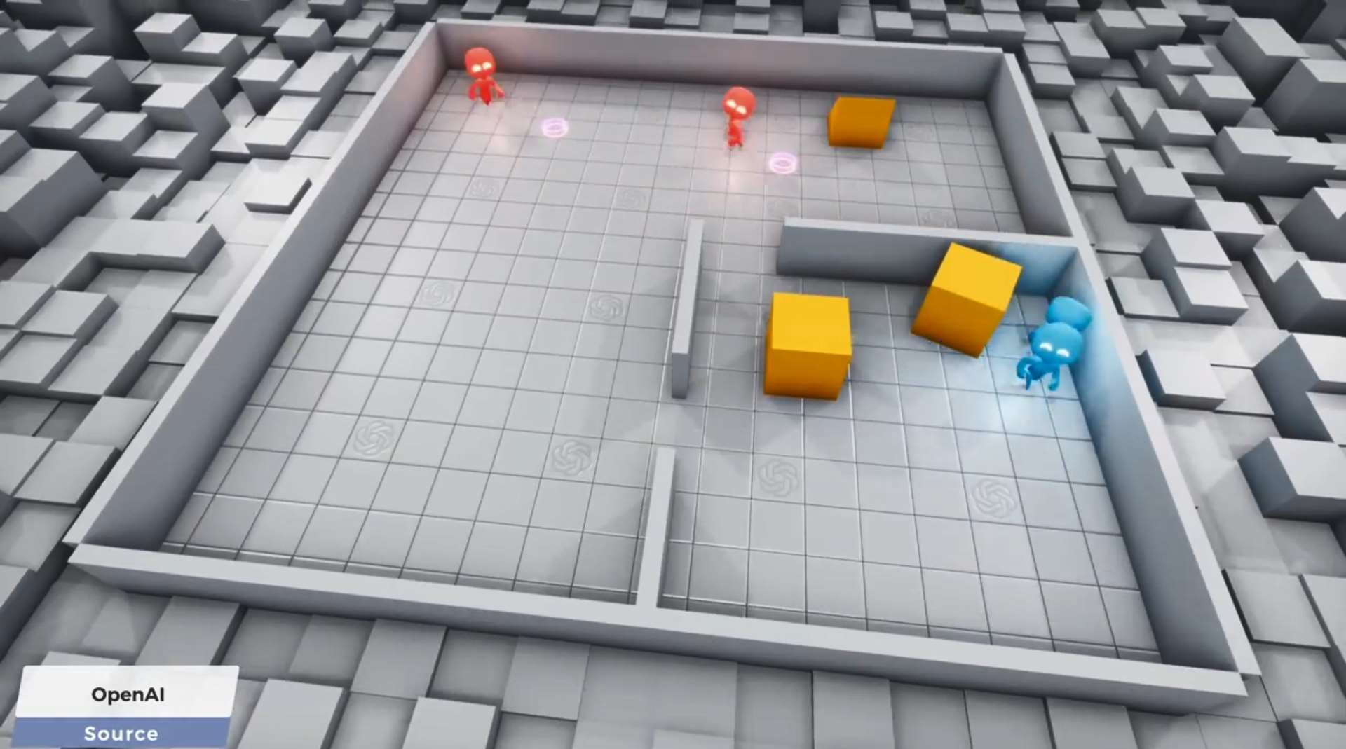

Fig 4.1 The environment created to train the bots

The seekers had a job of finding the hiders and hiders had a few seconds time to setup the environment before the Seekers becomes active and starts their action of catching the hiders. The mistakes they committed where transferred to next generation of bots and they learned from the mistakes made by predecessors.

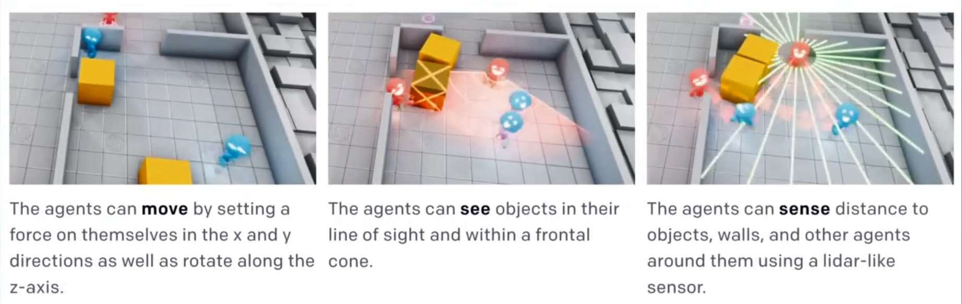

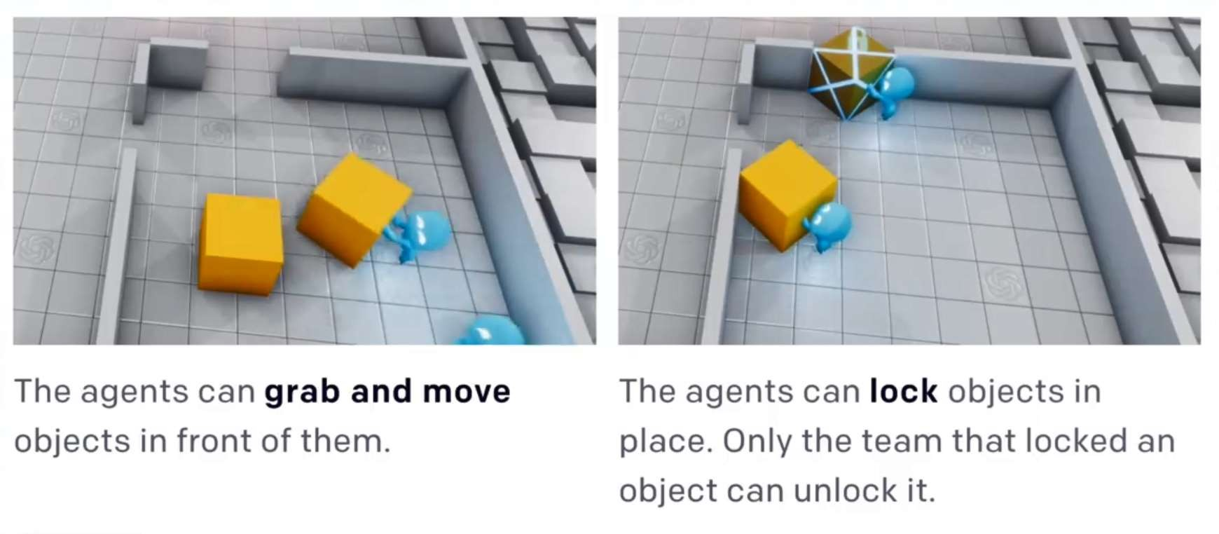

Fig 4.2 Mechanisms followed by the agents

The process is much complex and time consuming and for the first 2.6 million times (episode) the bots were trained, they moved freely without a proper motive and trying to learn the task. Around 2.69 million episodes later, the seekers found the mechanism to chase the hiders and catch them and this behavior continued until around 8.62 million episodes later the hiders learn to use the objects and block the doorway and starts to win now.

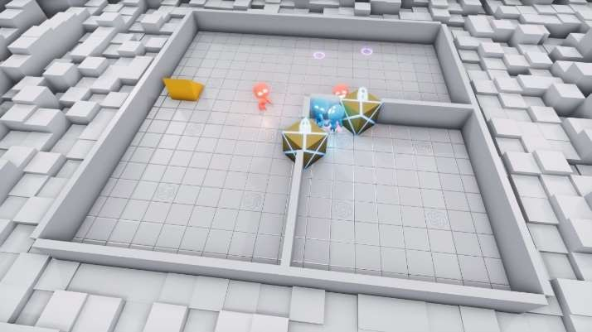 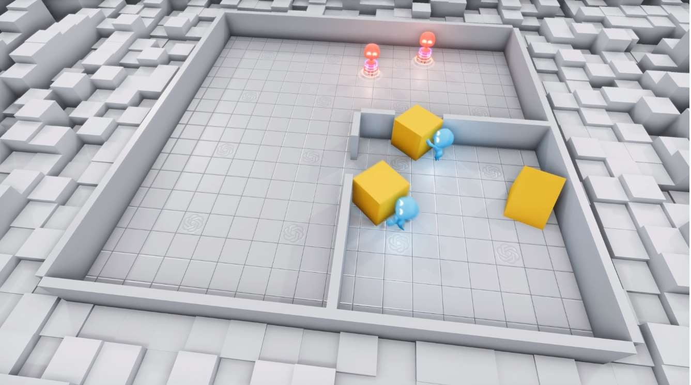

Fig 4.3 Seekers learned to block paths Fig 4.4 Seekers learned to take the ramp in

Right at the time when hiders learned to cover the doorway with blocks and blocking them. The seekers learned to use the ramp kept outside and jump in to catch the hiders. This continued until hiders finally learn to use the additional time provided them at the beginning of the round and intelligently bring that ramp inside and block all possible ways for seekers to come in.



It is to be noted that all of these human like brilliant and cunning strategies were learned by the robot themselves without the intervention of humans in between featuring the AI showing human like characteristics when it fully learns its surroundings.

# CHAPTER 5: SCENARIO 2: AI BEATING HUMANS



This chapters talks about another scenario where the AI beats humans in their own field of expertise. We knew until now that the ability to make strategy in real time and execute it accordingly, a skill honed by human which no animal or a bot has come closer to until recently in 2017. Where for the first time an AI beats humans in a complex video game. An OpenAI bot called OpenAI Five which is a team of five OpenAI-curated bots that are used in the competitive five-on-five video game Dota 2, who learn to play against human players at a high skill level entirely through trial-and- error algorithms. It trains using a scaled-up version of Proximal Policy Optimization running on 256 GPUs and 128,000 CPU cores and plays 180 years worth of games against itself every day. It took around 45,000 years of Dota 2 gameplay to reach its current level of ability. Which is still slower than what humans take to learn a game.

Dota 2 is a multiplayer online battle arena game, a style of strategy game where players coordinate to achieve strategic objectives like destroying or conquering enemy towers, ambushing enemy units, and upgrading and improving their own defenses. In Dota 2, each team has five players, each player directing their own “hero” with unique abilities. It’s a complex game with computer-controlled units on both sides, more than 100 potential “heroes” with different abilities, computer-controlled neutral units, an in- game economy, and a big map where players fight to destroy the enemy base while protecting their own.

By beating humans in such a complex real time strategy game it can be said that given enough time to train the AI will surely beat the humans not only in a game but in any given field of expertise hence contributing to the fact that we are more closer than ever to achieve the benchmarks of AGI.



# CONCLUSION

Developments in Artificial Intelligence is more quicker than ever it has been and AI’s or as we learned in the report above AGI’s are well within our graphs and soon see them in our daily lives. With the help of organisations such as OpenAI and many other AI researching companies contributing to raise the level of Modern AI. it’s impossible to deny that AIs are casually achieving things that would have been unimaginable only a few years ago. The two scenarios of AI showing human-like behaviors and beating humans in their own field innovatively provides enough support to say they have accomplished the motive of AGI and showed us the future possibilities of where AI might take us.

# RFERENCES



1. About OpenAI https://openai.com/about/ https://en.wikipedia.org/wiki/OpenAI
2. Two Minute Papers video on OpenAI Plays Hide and Seek…and Breaks The Game! https://youtu.be/Lu56xVlZ40M
3. Emergent Tool Use from Multi-Agent Interaction https://openai.com/blog/emergent-tool-use/
4. About Open AI five https://openai.com/blog/openai-five/
5. AI triumphs against the world’s top pro team in strategy game Dota 2 https://[www.vox.com/2019/4/13/18309418/open-ai-dota-triumph-og](http://www.vox.com/2019/4/13/18309418/open-ai-dota-triumph-og)
6. About Artificial General intelligence https://en.wikipedia.org/wiki/Artificial_general_intelligence